Programming Paradigms:

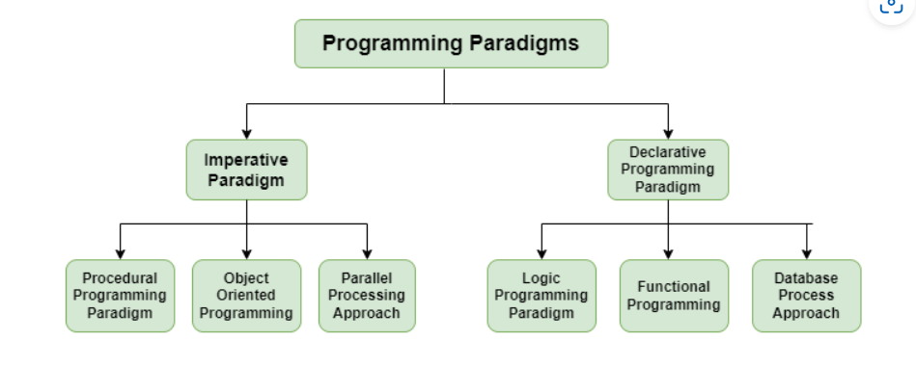

**1. Imperative Programming Paradigm**

It is a programming paradigm that works by changing the program state through assignment statements. The main focus in this paradigm is on how to achieve the goal. The following programming paradigms come under this category:

1. **Procedural Programming Paradigm**: This programming paradigm is based on the procedure call concept. Procedures, also known as routines or functions are the basic building blocks of a program in this paradigm.
2. **Object-Oriented Programming or OOP**: In this paradigm, we visualize every entity as an object and try to structure the program based on the state and behavior of that object.
3. **Parallel Programming**: The parallel programming paradigm is the processing of instructions by dividing them into multiple smaller parts and executing them concurrently.

**2. Declarative Programming Paradigm**

Declarative programming focuses on what is to be executed rather than how it should be executed. In this paradigm, we express the logic of a computation without considering its control flow. The declarative paradigm can be further classified into:

1. **Logical Programming Paradigm**: It is based on formal logic where the program statements express the facts and rules about the problem in the logical form.
2. **Functional Programming Paradigm**: Programs are created by applying and composing functions in this paradigm.
3. **Database Programming Paradigm**: To manage data and information organized as fields, records, and files, database programming models are utilized.
4. **13. What is the difference between Structured Programming and Object Oriented Programming?**

Structured Programming is a technique that is considered a precursor to OOP and usually consists of well-structured and separated modules. It is a subset of procedural programming. The difference between OOPs and Structured Programming is as follows:

| **Object-Oriented Programming** | **Structural Programming** |
| --- | --- |
| Programming that is object-oriented is built on objects having a state and behavior. | A program’s logical structure is provided by structural programming, which divides programs into their corresponding functions. |
| It follows a bottom-to-top approach. | It follows a Top-to-Down approach. |
| Restricts the open flow of data to authorized parts only providing better data security. | No restriction to the flow of data. Anyone can access the data. |
| Enhanced code reusability due to the concepts of polymorphism and inheritance. | Code reusability is achieved by using functions and loops. |
| In this, methods are written globally and code lines are processed one by one i.e., Run sequentially. | In this, the method works dynamically, making calls as per the need of code for a certain time. |
| Modifying and updating the code is easier. | Modifying the code is difficult as compared to OOPs. |
| Data is given more importance in OOPs. | Code is given more importance. |